LAB EXPERIMENTS
Experiment 1: DDL Commands using CREATE, ALTER, TRUNCATE and DROP
Aim
To study and implement the DDL (Data Definition Language) commands CREATE, ALTER, TRUNCATE, and DROP in MySQL.

Step 1: Create a Database
CREATE DATABASE University;

Step 2: Select the Database
USE University;

Step 3: Create a Table (CREATE)
CREATE TABLE Student (
StudentID INT,
Name VARCHAR(50),
Department VARCHAR(30),
Age INT
);

Step 4: View Table Structure
DESCRIBE Student;

Step 5: Add a New Column (ALTER ADD)
ALTER TABLE Student
ADD Email VARCHAR(50);

Step 6: Modify a Column (ALTER MODIFY)
ALTER TABLE Student
MODIFY Name VARCHAR(100);

Step 7: Rename a Column (ALTER RENAME COLUMN)
ALTER TABLE Student
RENAME COLUMN Department TO Dept;

Step 8: Drop a Column (ALTER DROP)
ALTER TABLE Student
DROP COLUMN Age;

Step 9: Insert Sample Records
INSERT INTO Student
VALUES
(101, 'Arun', 'CSE', 'arun@gmail.com'),
(102, 'Priya', 'ECE', 'priya@gmail.com');

Step 10: Display Records
SELECT * FROM Student;

Step 11: Remove All Records (TRUNCATE)
TRUNCATE TABLE Student;

Step 12: Verify Table is Empty
SELECT * FROM Student;

Step 13: Delete the Table (DROP)
DROP TABLE Student;

Step 14: Delete the Database
DROP DATABASE University;
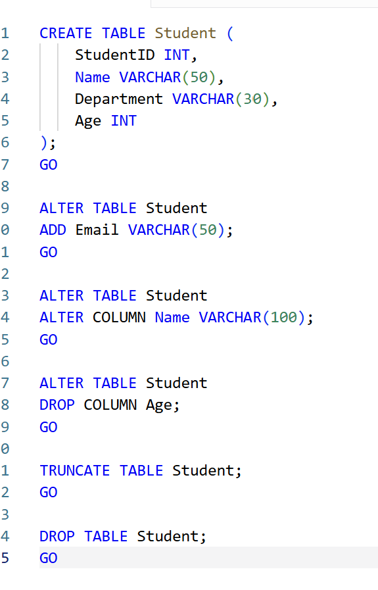
Experiment 2: DDL Commands with Constraints – PRIMARY KEY, FOREIGN KEY, UNIQUE, CHECK, DEFAULT, NOT NULL
Step 1: Create Database
CREATE DATABASE CollegeDB;
Step 2: Use Database
USE CollegeDB;
Step 3: Create Parent Table (Department)
CREATE TABLE Department (
DeptID INT PRIMARY KEY,
DeptName VARCHAR(30) UNIQUE
);
Step 4: Insert Data into Department
INSERT INTO Department VALUES
(101, 'CSE'),
(102, 'ECE'),
(103, 'MECH');
Step 5: Create Student Table with Constraints
CREATE TABLE Student (
StudentID INT PRIMARY KEY,
Name VARCHAR(50) NOT NULL,
Email VARCHAR(50) UNIQUE,
Age INT CHECK (Age >= 18),
City VARCHAR(30) DEFAULT 'Chennai',
DeptID INT,
FOREIGN KEY (DeptID) REFERENCES Department(DeptID)
);
Step 6: Insert Records
INSERT INTO Student (StudentID, Name, Email, Age, DeptID)
VALUES
(1, 'Arun', 'arun@gmail.com', 20, 101),
(2, 'Priya', 'priya@gmail.com', 19, 102),
(3, 'Rahul', 'rahul@gmail.com', 21, 103);
Step 7: View Records
SELECT * FROM Student;
